Getting back into the Window of Tolerance (Step 1)
adapted from Rothschilds 2000, 2014, 2016
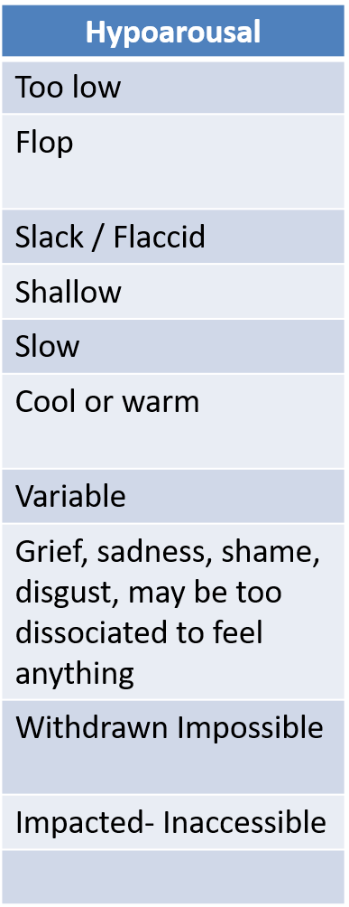
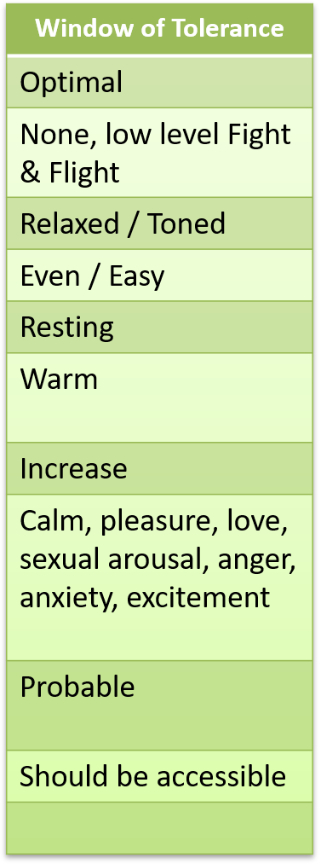
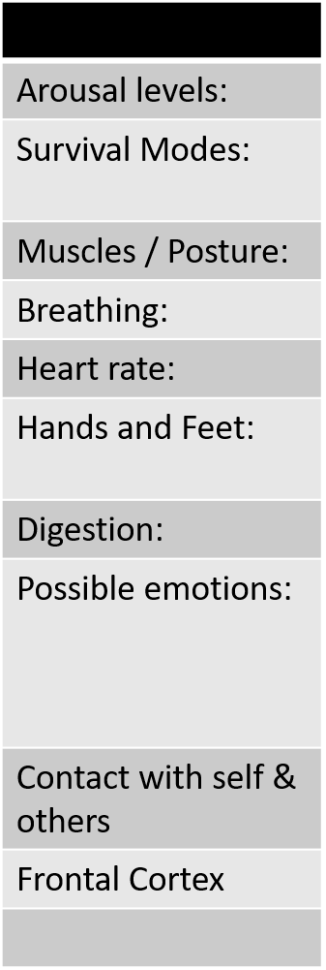
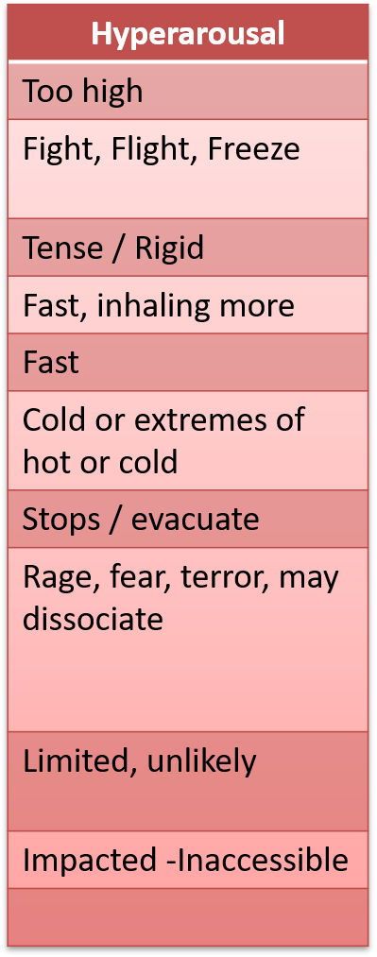

*N.B. these exist as a continuum and will be person/situation specific

Hypoarousal - What do I recognise in my client?

What do I need to do to help them back into the Window of Tolerance?
1
2
3
4
5
6

Hyperarousal - What do I recognise in my client?

What do I need to do to help them back into the Window of Tolerance?
1
2
3
4
5
6

